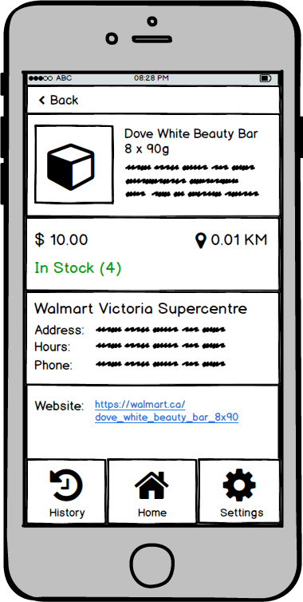

**Dove White Beauty Bor 8 x qOg**

SSLSLSLSSSLS SSLSLSSSLS LSSLSLSLSS SSLSLSSSLSLL LSSSSSSLSSL SSSSLSSSS LSL LSSLSLSLSSL SSSSSLLSSLLSSLLS

S 1O.OO In Stock (4)

**Walmart Victoria Supercentre**

**AddreSS. MMMMM MMMM MMMMMs Mars MMs**

Hours: SSLLSLSSSLS SLSLSLSLSL LSSLSLSSLSLSS SSLSLSL LSSSSLLLSSL

**Phone.**

Website. https://walmartical dove vhite beauty bor 8x90